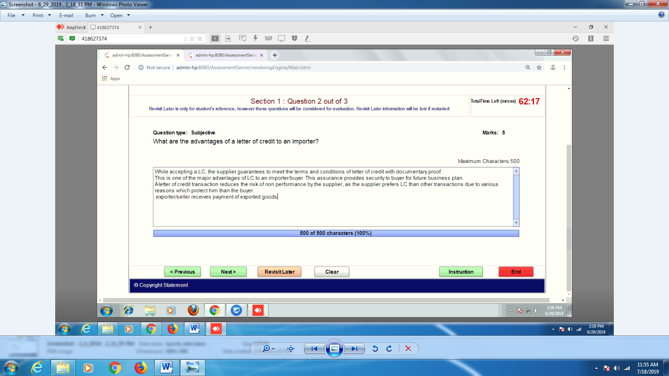Advantages of Letter of Credit to an Importer:
1) Importer is guaranteed to receive timely delivery of goods.
2) It makes structuring an advantageous payment schedule easy.
3) Expediting customs clearance and ultimate delivery as the documents are received quickly.
4) It gives an assurance to the importer that the payment will only be made to the exporter upon presentation of documents evidencing the shipment of goods.
5) It reduces the risk of non-performance of the exporter.
